# SENTIMENT ANALYSIS OF COMMODITY NEWS(GOLD)

AN INDUSTRY ORIENTED MINI REPORT

Submitted to

**JAWAHARLAL NEHRU TECNOLOGICAL UNIVERSITY, HYDERABAD**

In partial fulfillment of the requirements for the award of the degree of

**BACHELOR OF TECHNOLOGY**

**In**

**COMPUTER SCIENCE AND ENGINEERING(AI&ML)**

Submitted By

**SRILAXMI PORANDLA 21UK1A0502**

**AMULYA BHUPATHI 21UK1A0554**

**RAJKUMAR BANDI 21UK1A0549**

**RAJKUMAR DASARI 21UK1A0564**

Under the guidance of **Dr.P. Mahipal Reddy**

Assistant Professor



## DEPARTMENT OF COMPUTER SCIENCE AND ENGINEERING VAAGDEVI ENGINEERING COLLEGE

Affiliated to JNTUH, HYDERABAD BOLLIKUNTA, WARANGAL (T.S) – 506005

**DEPARTMENT OF**

**COMPUTER SCIENCE AND ENGINEERING**

**VAAGDEVI ENGINEERING COLLEGE(WARANGAL)**



**CERTIFICATE OF COMPLETION**

**INDUSTRY ORIENTED MINI PROJECT**

This is to certify that the UG Project Phase-1 entitled “SENTIMENT ANALYSIS OF COMMODITY NEWS (GOLD)” is being submitted by SRILAXMI PORANDLA(21UK1A0502), AMULYA BHUPATHI(2**1UK1A0554**), RAJKUMAR BANDI(**21UK1A0549**), RAJKUMAR DASARI (**21UK1A0564**) in partial fulfillment of the requirements for the award of the degree of Bachelor of Technology in Computer Science & Engineering to Jawaharlal Nehru Technological University Hyderabad during the academic year 2024- 2025.

**Project Guide HOD**

**Dr.P. Mahipal Reddy Dr. R. Naveen kumar**

(Assistant Professor) (Professor)

**External**

# ACKNOWLEDGEMENT

We wish to take this opportunity to express our sincere gratitude and deep sense of respect to our beloved **DR.SYED MUSHTAK AHMED,** Principal, Vaagdevi Engineering College for making us available all the required assistance and for his support and inspiration to carry out this UG Project Phase-1 in the institute.

We extend our heartfelt thanks to **Dr.R.NAVEEN KUMAR**, Head of the Department of CSE, Vaagdevi Engineering College for providing us necessary infrastructure and thereby giving us freedom to carry out the UG Project Phase-1.

We express heartfelt thanks to Smart Bridge Educational Services Private Limited, for their constant supervision as well as for providing necessary information regarding the UG Project Phase-1 and for their support in completing the UG Project Phase-1.

We express heartfelt thanks to the guide, **Dr.P**.**MAHIPAL REDDY ,** Assistant professor, Department of CSE for his constant support and giving necessary guidance for completion of this UG Project Phase-1.

Finally, we express our sincere thanks and gratitude to my family members, friends for their encouragement and outpouring their knowledge and experience throughout the thesis.

**SRILAXMI PORANDLA (21UK1A0502)**

**AMULYA BHUPATHI (21UK1A0554)**

**RAJKUMAR BANDI (21UK1A0549)**

**RAJKUMAR DASARI (21UK1A0564)**

# ABSTRACT

In order to analyse news stories on gold commodities and forecast market mood, this project creates a

machine learning model. The model is trained using text analysis and natural language processing

(NLP) on a tagged dataset of news items about gold. Accurately categorizing news stories as neutral,

negative, or favourable regarding their attitude toward gold is the aim in order to provide insights into

market opinions and trends. The research determines the best method for gold sentiment analysis by

comparing the performance of several machine learning algorithms. The result is a sentiment analysis

tool that can help traders, investors, and market analysts make well-informed decisions based on

sentiment in the market. This tool may have an effect on risk management and investing strategies in

the gold commodity market.

**TABLE OF CONTENTS:-**

1. INTRODUCTION 6
   1. OVERVIEW… 6
   2. PURPOSE 7
2. LITERATURE SURVEY 9
   1. EXISTING PROBLEM 9
   2. PROPOSED SOLUTION 9-10
3. THEORITICAL ANALYSIS 11-13
   1. BLOCK DIAGRAM 14
   2. HARDWARE /SOFTWARE DESIGNING 11-14
4. EXPERIMENTAL INVESTIGATIONS 15-16
5. FLOWCHART… 17
6. RESULTS… 18-19
7. ADVANTAGES AND DISADVANTAGES 20
8. APPLICATIONS 21
9. CONCLUSION 21
10. FUTURE SCOPE… 22
11. BIBILOGRAPHY 23
12. APPENDIX (SOURCE CODE)&CODE SNIPPETS 24-50

# OVERVIEW

## INTRODUCTION

In order to analyse news stories on gold commodities and forecast market mood, this project creates a machine learning model. The model is trained using text analysis and natural language processing (NLP) on a tagged dataset of news items about gold. Accurately categorizing news stories as neutral, negative, or favourable regarding their attitude toward gold is the aim in order to provide insights into market opinions and trends. The research determines the best method for gold sentiment analysis by comparing the performance of several machine learning algorithms. The result is a sentiment analysis tool that can help traders, investors, and market analysts make well-informed decisions based on sentiment in the market. This tool may have an effect on risk management and investing strategies in the gold commodity market.

Natural language processing (NLP) techniques are applied to news articles, social media posts, and other text data to ascertain the sentiment or emotional tone of the material. This process is known as sentiment analysis of commodity news, especially for gold. This procedure aids in the sentiment analysis of the market and the decision-making process for traders, investors, and analysts regarding gold trading. Here's a detailed summary:

Sentiment Analysis's Significance in Commodity Markets  
Market Sentiment: Knowing how the market is feeling generally about gold might help predict future price changes.  
Sentiment analysis is a tool that investors can use to help them make better educated trading decisions.

# PURPOSE

Sentiment analysis of commodities news, especially gold-related news, aims to glean insights about the sentiment and emotional tone of the market from textual data. These insights can have a big impact on trading tactics, investing choices, and risk management. The following are the main goals stated:

### **1. Market Sentiment Understanding**

**Objective:** Gauge the general mood or attitude towards gold in the market.

* **Why:** Market sentiment can significantly influence price movements. Positive sentiment often drives prices up, while negative sentiment can lead to price drops.
* **How:** By analyzing news articles, social media posts, and reports, sentiment analysis can provide a real-time or near-real-time understanding of market emotions.

### **2. Trading Strategies Development**

**Objective:** Create data-driven trading algorithms and strategies.

* **Why:** Sentiment-driven strategies can exploit market inefficiencies and predict short-term price movements.
* **How:** Algorithms can be designed to buy or sell gold based on the aggregated sentiment score from various sources.

### **3. Investment Decision Support**

**Objective:** Aid investors in making informed decisions.

* **Why:** Sentiment analysis offers additional layers of information beyond traditional financial metrics, helping investors understand the broader market perspective.
* **How:** Investors can use sentiment scores to complement fundamental and technical analysis, providing a more comprehensive view.

### **4. Risk Management**

**Objective:** Identify potential risks and mitigate them in time.

* **Why:** Negative sentiment can signal underlying risks or upcoming market downturns.
* **How:** Monitoring sentiment trends can help in early detection of negative news, allowing investors to adjust their portfolios and hedge against potential losses

### **5. Market Predictions**

**Objective:** Forecast future price movements of gold.

* **Why:** Historical sentiment data can be correlated with price movements to build predictive models.
* **How:** Machine learning models can use sentiment data as input to predict future price trends, helping investors anticipate market movements.

### **6. Portfolio Management**

**Objective:** Optimize and adjust investment portfolios.

* **Why:** Dynamic sentiment analysis allows for real-time adjustments to investment strategies.
* **How:** By continuously monitoring sentiment, portfolio managers can rebalance assets, reduce exposure to negative sentiment, and capitalize on positive sentiment.

# LITERATURE SURVEY

# EXISTING PROBLEM

Gold sentiment analysis in particular faces a number of obstacles and issues that compromise the analysis's dependability and accuracy. These are a few of the main concerns:  
  
1. Context Understanding Nuanced Language:

Sentiment analysis methods frequently struggle to appropriately read the complicated and nuanced language used in financial news.

Irony and Sarcasm: Interpreting irony and sarcasm can be very difficult, but it's important because these tones can significantly change the intended meaning.

2. Language Specific to a Domain

Financial Jargon: Generally speaking, sentiment analysis algorithms may not be able to manage the unique terminologies and jargon used in the financial industry.

Polysemy: It might be challenging for models to identify the right sentiment when words have many meanings in different circumstances.

**PROPOSED SOLUTION**

Advances in natural language processing (NLP), machine learning, and data engineering must be used to provide a multimodal approach to solving the current issues with sentiment analysis of commodities news, especially for gold. The following are some suggested fixes:  
  
1. Better Understanding of Context with Advanced NLP Models:  
  
Contextual Embeddings: Make use of models such as FinBERT or BERT (Bidirectional Encoder Representations from Transformers), which take into account the context and sentence structure as a whole in order to better grasp context.  
Fine-Tuning: To better capture the subtleties of financial language, fine-tune these pre-trained models exclusively on financial texts.  
Models that combine both:  
  
Combination of Techniques: To better capture the sentiment and context, combine machine learning models with rule-based systems. For example, hybrid models can combine deep learning and lexicon-based techniques to handle both particular financial

# THEORITICAL ANALYSIS

# BLOCK DIAGRAM

# 

* 1. **SOFTWARE DESIGNING**

The following is the Software required to complete this project:

* + - **Google Collab**: Google Collab will serve as the development and execution environment for your predictive modeling, data preprocessing, and model training tasks. It provides a cloud-based Jupyter Notebook environment with access to Python libraries and hardware acceleration.
    - **Dataset (CSV File)**: The dataset in CSV format is essential for training and testing your predictive model. It should include historical air quality data, weather information, pollutant levels, and other relevant features.
    - **Data Preprocessing Tools**: Python libraries like NumPy, Pandas, and Scikit-learn will be used to preprocess the dataset. This includes handling missing data, feature scaling, and data cleaning.
    - **Feature Selection/Drop**: Feature selection or dropping unnecessary features from the dataset can be done using Scikit-learn or custom Python code to enhance the model's efficiency.
    - **Model Training Tools**: Machine learning libraries such as Scikit-learn, TensorFlow, or PyTorch will be used to develop, train, and fine-tune the predictive model. Regression or classification models can be considered, depending on the nature of the gold commodity prediction task.
    - **Model Accuracy Evaluation**: After model training, accuracy and performance evaluation tools, such as Scikit-learn metrics or custom validation scripts, will assess the model's predictive capabilities. You'll measure the model's ability to predict gold headlines categories based on historical data.
    - **UI Based on Flask Environment**: Flask, a Python web framework, will be used to develop the user interface (UI) for the system. The Flask application will provide a user-friendly platform for users to input location data or view commodity (gold) predictions, health information, and recommended precautions.
    - Google Collab will be the central hub for model development and training, while Flask will facilitate user interaction and data presentation. The dataset, along with data preprocessing, will ensure the quality of the training data, and feature selection will optimize the model. Finally, model accuracy evaluation will confirm the system's predictive capabilities, allowing users to rely on the predictions and associated information.

# EXPERIMENTAL INVESTIGATION

In this project, we have used Sentiment Analysis of commodity news(gold). This dataset is a csv file consisting of labelled data and having the following columns-

1. **Dates**: It specifies the date of news headline.
2. **URL**: It specifies the URL of news headline.
3. **News**: It specifies the news headlines about the gold.
4. **Price Direction Up**: it specifies whether the news headline imply price direction up?
5. **Price Direction constant**: it specifies whether the news headline imply price direction sideways?
6. **Price Direction Down**: it specifies whether the news headline imply price direction down?
7. **Asset Comparision**: it specifies whether the assets are being compared or not.
8. **Past Information**: it specifies if the news headline is talking about the past.
9. **Future Information**: it specifies if the news headline is talking about the future.
10. **Price Sentiment**: it specifies the Price Sentiment of Gold commodity based on headline.

For the dataset we selected, it consists of more than the columns we want to predict it . So, we have chosen the feature drop it contains the columns that we are going to predict the AQI value.

* + Feature drop means it drops the columns that we don’t want in our dataset.
  + Feature_drop = ['PM10','NH3','Benzene','Toluene','Xylene','index']

# FLOWCHART

# 

1. **RESULT**

**HOME PAGE**

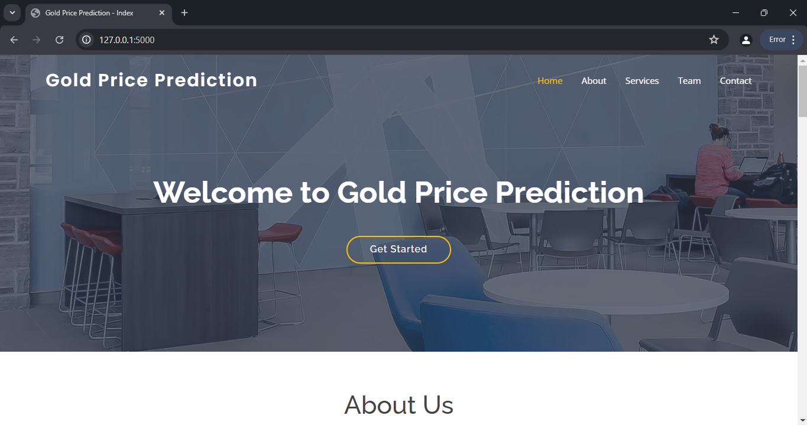

**PREDICTIONS**

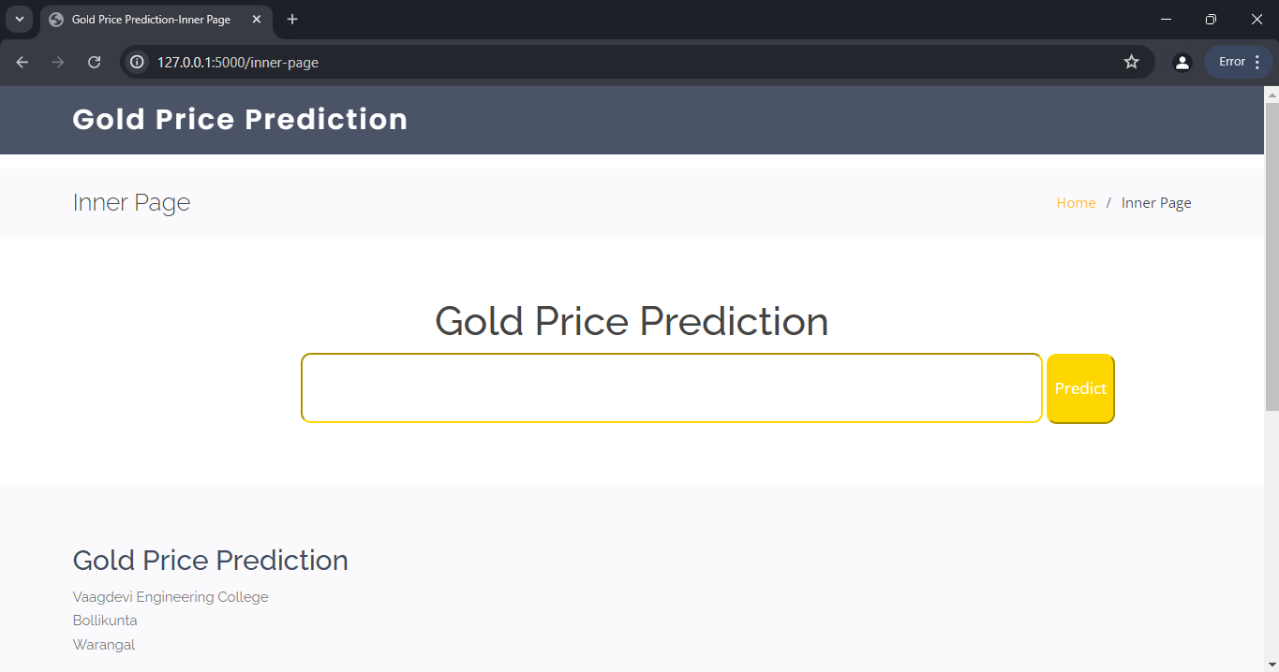

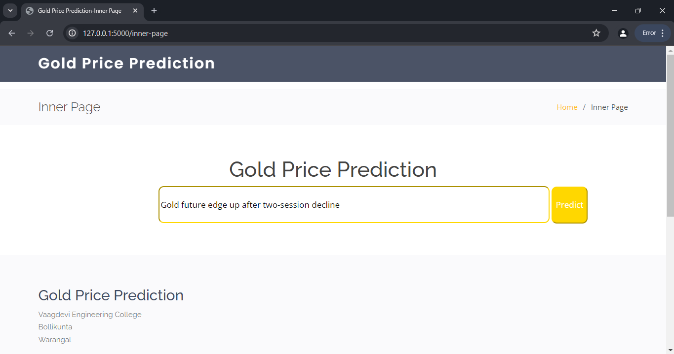

**RESULT**

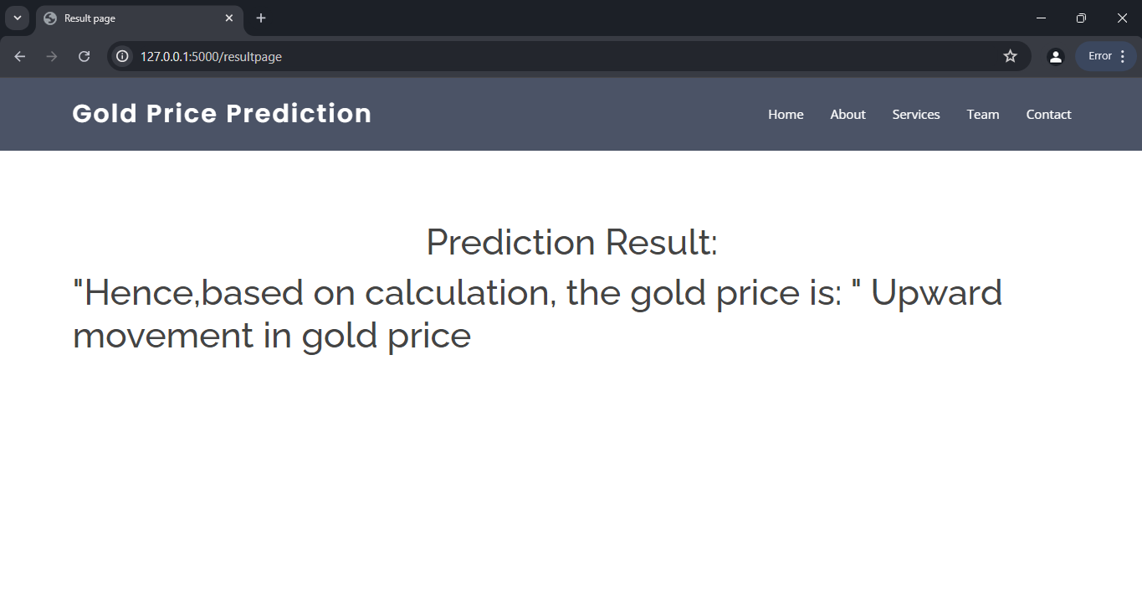

# ADVANTAGES AND DISADVANTAGES

## ADVANTAGES:

• **Market Sentiment Insights**: It gauges the overall mood of market participants, indicating potential future price directions.

• **Predictive Analytics**: Analyzing sentiment helps develop models to forecast gold price movements based on positive or negative news trends.

• **Risk Management**: Monitoring sentiment changes identifies emerging risks, allowing investors to adjust portfolios and mitigate potential losses.

• **Investment Strategy Development**: It informs refined investment strategies by indicating bullish or bearish trends in gold.

• **Competitive Advantage**: Enables quicker, more informed decision-making, providing a market edge over traditional analysis methods.

## DISADVANTAGES:

• **Data Misinterpretation**: Sentiment analysis algorithms can misinterpret sarcasm, irony, or complex language, leading to inaccurate sentiment assessments.

• **Bias in Data Sources**: News sources may have inherent biases, affecting the sentiment analysis outcome and providing a skewed market view.

• **Overreaction to News**: Relying heavily on sentiment analysis might lead to overreacting to short-term news, causing impulsive and potentially harmful trading decisions.

• **Complexity of Integration**: Integrating sentiment analysis with existing trading systems can be complex and resource-intensive, requiring significant technical expertise.

# APPLICATIONS

• **Trading Algorithms**: Enhances automated trading systems by incorporating sentiment data to make more informed buy and sell decisions.

• **Market Research**: Assists analysts in understanding market trends and investor sentiment, improving market forecasts and investment recommendations.

• **Portfolio Management**: Helps portfolio managers adjust asset allocations based on sentiment shifts, optimizing investment performance.

• **Regulatory Monitoring**: Enables regulators to monitor market sentiment for signs of market manipulation or abnormal trading activities.

# CONCLUSION

Sentiment analysis of commodity news for gold offers significant advantages, such as providing market sentiment insights, enhancing predictive analytics, aiding in risk management, informing investment strategies, and offering a competitive advantage. However, it also presents challenges like potential data misinterpretation, biases in data sources, overreaction to news, and the complexity of integration. Despite these drawbacks, its applications in trading algorithms, market research, portfolio management, and regulatory monitoring underscore its value. Overall, sentiment analysis stands as a powerful tool for navigating the dynamic and often unpredictable gold market.

* Sentiment analysis of commodity news for gold provides valuable insights into market sentiment, enhances predictive capabilities, and supports risk management and investment strategies. While challenges like data misinterpretation and biases exist, the benefits in applications such as trading algorithms and portfolio management highlight its importance. Overall, it is a powerful tool for understanding and navigating the gold market.

# FUTURE SCOPE

Future Scope of the AQI Prediction and Management System:

• **Enhanced Accuracy with AI**: Advancements in artificial intelligence and machine learning will improve the accuracy of sentiment analysis, reducing errors from misinterpretation of complex language.

• **Real-time Analysis**: Future developments will enable more sophisticated real-time sentiment analysis, providing instant insights into market sentiment changes.

• **Integration with Big Data**: Combining sentiment analysis with big data analytics will offer deeper insights by analyzing vast amounts of structured and unstructured data from diverse sources.

• **Personalized Investment Strategies**: Sentiment analysis will be increasingly used to develop highly personalized investment strategies, tailored to individual investor profiles and risk appetites.

# BIBILOGRAPHY

• Bollen, J., Mao, H., & Zeng, X. (2011). Twitter mood predicts the stock market. Journal of Computational Science, 2(1), 1-8.

• Nassirtoussi, A. K., Aghabozorgi, S., Wah, T. Y., & Ngo, D. C. L. (2014). Text mining for market prediction: A systematic review. Expert Systems with Applications, 41(16), 7653-7670.

• Tetlock, P. C. (2007). Giving content to investor sentiment: The role of media in the stock market. The Journal of Finance, 62(3), 1139-1168.

• Rao, T., & Srivastava, S. (2012). Analyzing stock market movements using Twitter sentiment analysis. Proceedings of the 2012 International Conference on Advances in Social Networks Analysis and Mining, 119-123.

• Schumaker, R. P., & Chen, H. (2009). Textual analysis of stock market prediction using breaking financial news: The AZFin text system. ACM Transactions on Information Systems, 27(2), 1-19.

• Luss, R., & D'Aspremont, A. (2012). Predicting abnormal returns from news using text classification. Quantitative Finance, 12(4), 495-512.

• Hagenau, M., Liebmann, M., & Neumann, D. (2013). Automated news reading: Stock price prediction based on financial news using context-capturing features. Decision Support Systems, 55(3), 685-697

# 10. APPENDIX

**Model Building :**

1. Dataset
2. Google colab and VS code Application Building
   1. HTML file (Index file, Predict file )
3. CSS file
4. Models in pickle format

## SOURCE CODE:

**INDEX.HTML**

<!DOCTYPE html>

<html lang="en">

<head>

<meta charset="utf-8">

<meta content="width=device-width, initial-scale=1.0" name="viewport">

<title>Gold Price Prediction - Index</title>

<meta content="" name="description">

<meta content="" name="keywords">

<!-- Favicons

<link href="C:\Users\SHIVA KUMAR\OneDrive\Desktop\mini project\Flask\Static\assets\img\favicon.png" rel="icon">

<link href="C:/Users/SHIVA KUMAR/OneDrive/Desktop/mini project/Flask/Static/assets/img/apple-touch-icon.png" rel="apple-touch-icon">-->

<!-- Google Fonts -->

<link href="https://fonts.googleapis.com/css?family=Open+Sans:300,300i,400,400i,600,600i,700,700i|Raleway:300,300i,400,400i,500,500i,600,600i,700,700i|Poppins:300,300i,400,400i,500,500i,600,600i,700,700i" rel="stylesheet">

<!-- Vendor CSS Files -->

<link href="../static/assets/vendor/bootstrap/css/bootstrap.min.css" rel="stylesheet">

<link href="../static/assets/vendor/bootstrap-icons/bootstrap-icons.css" rel="stylesheet">

<link href="../static/assets/vendor/boxicons/css/boxicons.min.css" rel="stylesheet">

<link href="../static/assets/vendor/glightbox/css/glightbox.min.css" rel="stylesheet">

<link href="../static/assets/vendor/swiper/swiper-bundle.min.css" rel="stylesheet">

<!-- Template Main CSS File -->

<link href="../static/assets/css/style.css" rel="stylesheet">

</head>

<body>

<!-- ======= Header ======= -->

<header id="header" class="fixed-top header-transparent">

<div class="container d-flex align-items-center justify-content-between">

<h1 class="logo"><a href="inner-page.html">Gold Price Prediction</a></h1>

<!-- Uncomment below if you prefer to use an image logo -->

<!-- <a href="index.html" class="logo"><img src="assets/img/logo.png" alt="" class="img-fluid"></a>-->

<nav id="navbar" class="navbar">

<ul>

<li><a class="nav-link scrollto active" href="#hero">Home</a></li>

<li><a class="nav-link scrollto" href="#about">About</a></li>

<li><a class="nav-link scrollto" href="#services">Services</a></li>

<li><a class="nav-link scrollto" href="#team">Team</a></li>

<li><a class="nav-link scrollto" href="#contact">Contact</a></li>

</ul>

<i class="bi bi-list mobile-nav-toggle"></i>

</nav><!-- .navbar -->

</div>

</header><!-- End Header -->

<!-- ======= Hero Section ======= -->

<section id="hero" class="d-flex align-items-center justify-content-center">

<div class="container position-relative">

<h1>Welcome to Gold Price Prediction</h1>

<a href="/inner-page" class="btn-get-started scrollto">Get Started</a>

</div>

</section><!-- End Hero -->

<main id="main">

<!-- ======= Clients Section ======= -->

<!-- End Clients Section -->

<!-- ======= About Section ======= -->

<section id="about" class="about">

<h1 style="text-align: center;">About Us</h1>

<div class="container">

<div class="row">

<div class="col-lg-6">

<img src="../static/assets/img/about.jpg" class="img-fluid" alt="">

</div>

<div class="col-lg-6 pt-4 pt-lg-0">

<h3>The Trusted Place on the Earth</h3>

<div class="col-md-6">

<i class="bx bx-receipt"></i>

<h4>Protect your wealth with the timeless value of gold</h4>

<p>Its important that gold Predictions are just that-predictions-and that actual gold prices can vary greatly from what was forecasted. As with any investment ,it is important to do thorough research and seek proffesional advice before making any decisions about investing in gold.</p>

</div>

</div>

</div>

</div>

</section><!-- End About Section -->

<!-- ======= Counts Section ======= -->

<section id="counts" class="counts section-bg">

<div class="container">

<div class="row counters">

<div class="col-lg-3 col-6 text-center">

<span data-purecounter-start="0" data-purecounter-end="232" data-purecounter-duration="1" class="purecounter"></span>

<p>Clients</p>

</div>

<div class="col-lg-3 col-6 text-center">

<span data-purecounter-start="0" data-purecounter-end="521" data-purecounter-duration="1" class="purecounter"></span>

<p>Projects</p>

</div>

<div class="col-lg-3 col-6 text-center">

<span data-purecounter-start="0" data-purecounter-end="1463" data-purecounter-duration="1" class="purecounter"></span>

<p>Hours Of Support</p>

</div>

<div class="col-lg-3 col-6 text-center">

<span data-purecounter-start="0" data-purecounter-end="15" data-purecounter-duration="1" class="purecounter"></span>

<p>Hard Workers</p>

</div>

</div>

</div>

</section><!-- End Counts Section -->

<!-- ======= Services Section ======= -->

<section id="services" class="services">

<div class="container">

<div class="section-title">

<h2>Services</h2>

<p>Here are the services we provide!</p>

</div>

<div class="row">

<h1 style="text-align: center;">Customer acquisition</h1>

<a href="/inner-page"> <button style="width:100px;margin-left: 580px;" >prediction</button></a>

</div>

</div>

</section><!-- End Services Section -->

<!-- ======= Cta Section ======= -->

<section id="cta" class="cta">

<div class="container">

<div class="text-center">

<h3>Call To Action</h3>

<p> You are redirected to home Page </p>

<a class="cta-btn" href="#">Call To Action</a>

</div>

</div>

</section><!-- End Cta Section -->

<!-- ======= Testimonials Section ======= -->

<!-- End Testimonials Section -->

<!-- ======= Portfolio Section ======= -->

<!-- End Portfolio Section -->

<!-- ======= Team Section ======= -->

<section id="team" class="team section-bg">

<div class="container">

<div class="section-title">

<h2>Team</h2>

<p>We are a team of 4 members namely Srilaxmi Porandla, Amulya Bhupathi, Rajkumar Bandi, Rajkumar Dasari.</p>

</div>

<div class="row">

<div class="col-lg-3 col-md-6 d-flex align-items-stretch">

<div class="member">

<div class="member-img">

<img src="" class="img-fluid" alt="">

<div class="social">

<a href=""><i class="bi bi-twitter"></i></a>

<a href=""><i class="bi bi-facebook"></i></a>

<a href=""><i class="bi bi-instagram"></i></a>

<a href=""><i class="bi bi-linkedin"></i></a>

</div>

</div>

<div class="member-info">

<h4>Srilaxmi Porandla</h4>

<span>21UK1A0502</span>

</div>

</div>

</div>

<div class="col-lg-3 col-md-6 d-flex align-items-stretch">

<div class="member">

<div class="member-img">

<img src="" class="img-fluid" alt="">

<div class="social">

<a href=""><i class="bi bi-twitter"></i></a>

<a href=""><i class="bi bi-facebook"></i></a>

<a href=""><i class="bi bi-instagram"></i></a>

<a href=""><i class="bi bi-linkedin"></i></a>

</div>

</div>

<div class="member-info">

<h4>Amulya Bhupathi</h4>

<span>21UK1A0554</span>

</div>

</div>

</div>

<div class="col-lg-3 col-md-6 d-flex align-items-stretch">

<div class="member">

<div class="member-img">

<img src="" class="img-fluid" alt="">

<div class="social">

<a href=""><i class="bi bi-twitter"></i></a>

<a href=""><i class="bi bi-facebook"></i></a>

<a href=""><i class="bi bi-instagram"></i></a>

<a href=""><i class="bi bi-linkedin"></i></a>

</div>

</div>

<div class="member-info">

<h4>Rajkumar Bandi</h4>

<span>21UK1A0549</span>

</div>

</div>

</div>

<div class="col-lg-3 col-md-6 d-flex align-items-stretch">

<div class="member">

<div class="member-img">

<img src="" class="img-fluid" alt="">

<div class="social">

<a href=""><i class="bi bi-twitter"></i></a>

<a href=""><i class="bi bi-facebook"></i></a>

<a href=""><i class="bi bi-instagram"></i></a>

<a href=""><i class="bi bi-linkedin"></i></a>

</div>

</div>

<div class="member-info">

<h4>Rajkumar Dasari</h4>

<span>21UK1A0564</span>

</div>

</div>

</div>

</div>

</div>

</section><!-- End Team Section -->

<!-- ======= Pricing Section ======= -->

<!-- End Pricing Section -->

<!-- ======= Frequently Asked Questions Section ======= -->

<!-- End Frequently Asked Questions Section -->

<!-- ======= Contact Section ======= -->

<section id="contact" class="contact">

<div class="container">

<div class="section-title">

<h2>Contact</h2>

</div>

<div class="row">

<div class="col-lg-6">

<div class="row">

<div class="col-md-12">

<div class="info-box">

<i class="bx bx-map"></i>

<h3>Our Address</h3>

<p>Vaagdevi Engineering College, Bollikunta,Warangal</p>

</div>

</div>

<div class="col-md-6">

<div class="info-box mt-4">

<i class="bx bx-envelope"></i>

<h3>Email Us</h3>

<p>porandlasrilaxmi41@gmail.com<br>bhupathiamulya1@gmail.com

<br>bandirajkumar834@gmail.com<br>rajkumardasari925@gmail.com</p>

</div>

</div>

<div class="col-md-6">

<div class="info-box mt-4">

<i class="bx bx-phone-call"></i>

<h3>Call Us</h3>

<p>7013717808<br>7801049870<br>7132190958

<br>9381406582

</p>

</div>

</div>

</div>

</div>

<!-- <div class="col-lg-6">

<form action="forms/contact.php" method="post" role="form" class="php-email-form">

<div class="row">

<div class="col-md-6 form-group">

<input type="text" name="name" class="form-control" id="name" placeholder="Your Name" required>

</div>

<div class="col-md-6 form-group mt-3 mt-md-0">

<input type="email" class="form-control" name="email" id="email" placeholder="Your Email" required>

</div>

</div>

<div class="form-group mt-3">

<input type="text" class="form-control" name="subject" id="subject" placeholder="Subject" required>

</div>

<div class="form-group mt-3">

<textarea class="form-control" name="message" rows="5" placeholder="Message" required></textarea>

</div>

<div class="my-3">

<div class="loading">Loading</div>

<div class="error-message"></div>

<div class="sent-message">Your message has been sent. Thank you!</div>

</div>

<div class="text-center"><button type="submit">Send Message</button></div>

</form>

</div> -->

</div>

</div>

</section><!-- End Contact Section -->

</main><!-- End #main -->

<!-- ======= Footer ======= -->

<footer id="footer">

<div class="footer-top">

<div class="container">

<div class="row">

<div class="col-lg-3 col-md-6 footer-contact">

<h3>Gold Price Prediction</h3>

<p>

Vaagdevi Engineering College <br>

Bollikunta<br>

Warangal <br><br>

<strong>Phone:</strong>7013717808<br>

<strong>Email:</strong>porandlasrilaxmi41@gmail.com<br>

</p>

</div>

<!--<div class="col-lg-2 col-md-6 footer-links">

<h4>Useful Links</h4>

<ul>

<li><i class="bx bx-chevron-right"></i> <a href="#">Home</a></li>

<li><i class="bx bx-chevron-right"></i> <a href="#">About us</a></li>

<li><i class="bx bx-chevron-right"></i> <a href="#">Services</a></li>

<li><i class="bx bx-chevron-right"></i> <a href="#">Terms of service</a></li>

<li><i class="bx bx-chevron-right"></i> <a href="#">Privacy policy</a></li>

</ul>

</div>-->

</div>

</div>

</div>

<div class="container d-md-flex py-4">

<div class="me-md-auto text-center text-md-start">

<div class="copyright">

&copy; Copyright <strong><span>Gold Price Prediction</span></strong>. All Rights Reserved

</div>

</div>

<!--<div class="social-links text-center text-md-right pt-3 pt-md-0">

<a href="#" class="twitter"><i class="bx bxl-twitter"></i></a>

<a href="#" class="instagram"><i class="bx bxl-instagram"></i></a>

<a href="#" class="linkedin"><i class="bx bxl-linkedin"></i></a>

</div> -->

</div>

</footer><!-- End Footer -->

<a href="#" class="back-to-top d-flex align-items-center justify-content-center"><i class="bi bi-arrow-up-short"></i></a>

<!-- Vendor JS Files -->

<script src="../static/assets/vendor/purecounter/purecounter_vanilla.js"></script>

<script src="../static/assets/vendor/bootstrap/js/bootstrap.bundle.min.js"></script>

<script src="../static/assets/vendor/glightbox/js/glightbox.min.js"></script>

<script src="../static/assets/vendor/isotope-layout/isotope.pkgd.min.js"></script>

<script src="../static/assets/vendor/swiper/swiper-bundle.min.js"></script>

<script src="../static/assets/vendor/php-email-form/validate.js"></script>

<!-- Template Main JS File -->

<script src="../static/assets/js/main.js"></script>

</body>

</html>

## PREDICT.HTML

<!DOCTYPE html>

<html lang="en">

<head>

<meta charset="utf-8">

<meta content="width=device-width, initial-scale=1.0" name="viewport">

<title>Gold Price Prediction-Inner Page</title>

<meta content="" name="description">

<meta content="" name="keywords">

<!--

<link href="../static/assets/img/favicon.png" rel="icon"> -->

<link href="../static/assets/img/apple-touch-icon.png" rel="apple-touch-icon">

<!-- Google Fonts -->

<link href="https://fonts.googleapis.com/css?family=Open+Sans:300,300i,400,400i,600,600i,700,700i|Raleway:300,300i,400,400i,500,500i,600,600i,700,700i|Poppins:300,300i,400,400i,500,500i,600,600i,700,700i" rel="stylesheet">

<!-- Vendor CSS Files -->

<link href="../static/assets/vendor/bootstrap/css/bootstrap.min.css" rel="stylesheet">

<link href="../static/assets/vendor/bootstrap-icons/bootstrap-icons.css" rel="stylesheet">

<link href="../static/assets/vendor/boxicons/css/boxicons.min.css" rel="stylesheet">

<link href="../static/assets/vendor/glightbox/css/glightbox.min.css" rel="stylesheet">

<link href="../static/assets/vendor/swiper/swiper-bundle.min.css" rel="stylesheet">

<!-- Template Main CSS File -->

<link href="../static/assets/css/style.css" rel="stylesheet">

<!-- =======================================================

* Template Name: Baker

* Template URL: https://bootstrapmade.com/baker-free-onepage-bootstrap-theme/

* Updated: Mar 17 2024 with Bootstrap v5.3.3

* Author: BootstrapMade.com

* License: https://bootstrapmade.com/license/

======================================================== -->

</head>

<body>

<!-- ======= Header ======= -->

<header id="header" class="fixed-top ">

<div class="container d-flex align-items-center justify-content-between">

<h1 class="logo"><a href="index.html">Gold Price Prediction</a></h1>

<!-- Uncomment below if you prefer to use an image logo -->

<!-- <a href="index.html" class="logo"><img src="assets/img/logo.png" alt="" class="img-fluid"></a>-->

<!-- <nav id="navbar" class="navbar">

<ul>

<li><a class="nav-link scrollto " href="index.html">Home</a></li>

<li><a class="nav-link scrollto" href="index.html">About</a></li>

<li><a class="nav-link scrollto" href="index.html">Services</a></li>

<li><a class="nav-link scrollto" href="index.html">Team</a></li>

<li><a class="nav-link scrollto" href="index.html">Contact</a></li>

</ul>

<i class="bi bi-list mobile-nav-toggle"></i>

</nav>

-->

</div>

</header><!-- End Header -->

<main id="main">

<!-- ======= Breadcrumbs ======= -->

<section class="breadcrumbs">

<div class="container">

<div class="d-flex justify-content-between align-items-center">

<h2>Inner Page</h2>

<ol>

<li><a href="index.html">Home</a></li>

<li>Inner Page</li>

</ol>

</div>

</div>

</section><!-- End Breadcrumbs -->

<style>

.predicting form #pre{

width: 740px;

margin-left: 300px;

height:70px;

border-radius: 10px;

border-color:gold;

}

.predicting form #pre1{

height:70px;

border-radius: 10px;

border-color:gold;

background-color: gold;

color:white;

}

</style>

<section class="predicting">

<h1 style="text-align: center;">Gold Price Prediction</h1>

<form action="{{url_for('predictionpage')}}"method="POST">

<input type="text" id="pre" name="headline">

<input type="submit"value="Predict" id="pre1" >

<!-- <form >

<button type="submit" id="predbut">Predict</button></form>

</form>-->

</section>

</main><!-- End #main -->

<!-- ======= Footer ======= -->

<footer id="footer">

<div class="footer-top">

<div class="container">

<div class="row">

<div class="col-lg-3 col-md-6 footer-contact">

<h3>Gold Price Prediction</h3>

<p>

Vaagdevi Engineering College <br>

Bollikunta<br>

Warangal<br><br>

<strong>Phone:</strong> 7013717818<br>

<strong>Email:</strong>porandlasrilaxmi41@gmail.com<br>

</p>

</div>

<div class="col-lg-2 col-md-6 footer-links">

<h4>Useful Links</h4>

<ul>

<li><i class="bx bx-chevron-right"></i> <a href="index.html">Home</a></li>

<li><i class="bx bx-chevron-right"></i> <a href="index.html">About us</a></li>

<li><i class="bx bx-chevron-right"></i> <a href="index.html">Services</a></li>

</ul>

</div>

<div class="col-lg-3 col-md-6 footer-links">

<h4>Our Services</h4>

<ul>

<li><i class="bx bx-chevron-right"></i> <a href="#">Gold Price Prediction</a></li>

</ul>

</div>

</div>

</div>

</div>

<div class="container d-md-flex py-4">

<div class="me-md-auto text-center text-md-start">

<div class="copyright">

&copy; Copyright <strong><span>Gold Price Prediction</span></strong>. All Rights Reserved

</div>

<div class="credits">

<!-- You can delete the links only if you purchased the pro version.

Licensing information: https://bootstrapmade.com/license/

Purchase the pro version with working PHP/AJAX contact form: https://bootstrapmade.com/baker-free-onepage-bootstrap-theme/

Designed by <a href="https://bootstrapmade.com/">BootstrapMade</a>-->

</div>

</div>

<div class="social-links text-center text-md-right pt-3 pt-md-0">

<a href="#" class="twitter"><i class="bx bxl-twitter"></i></a>

<a href="#" class="google-plus"><i class="bx bxl-skype"></i></a>

<a href="#" class="linkedin"><i class="bx bxl-linkedin"></i></a>

</div>

</div>

</footer><!-- End Footer -->

<a href="#" class="back-to-top d-flex align-items-center justify-content-center"><i class="bi bi-arrow-up-short"></i></a>

<!-- Vendor JS Files -->

<script src="../static/assets/vendor/purecounter/purecounter_vanilla.js"></script>

<script src="../static/assets/vendor/bootstrap/js/bootstrap.bundle.min.js"></script>

<script src="../static/assets/vendor/glightbox/js/glightbox.min.js"></script>

<script src="../static/assets/vendor/isotope-layou/isotope.pkgd.min.js"></script>

<script src="../static/assets/vendor/swiper/swiper-bundle.min.js"></script>

<script src="../static/assets/vendor/php-email-form/validate.js"></script>

<!-- Template Main JS File -->

<script src="../static/assets/js/main.js"></script>

</body>

</html>

## RESULT PAGE

## <!DOCTYPE html>

## <html lang="en">

## <head>

## <meta charset="utf-8">

## <meta content="width=device-width, initial-scale=1.0" name="viewport">

## <title>Result page</title>

## <meta content="" name="description">

## <meta content="" name="keywords">

## <!-- Google Fonts -->

## <link href="https://fonts.googleapis.com/css?family=Open+Sans:300,300i,400,400i,600,600i,700,700i|Raleway:300,300i,400,400i,500,500i,600,600i,700,700i|Poppins:300,300i,400,400i,500,500i,600,600i,700,700i" rel="stylesheet">

## <!-- Vendor CSS Files -->

## <link href="../static/assets/vendor/bootstrap/css/bootstrap.min.css" rel="stylesheet">

## <link href="../static/assets/vendor/bootstrap-icons/bootstrap-icons.css" rel="stylesheet">

## <link href="../static/assets/vendor/boxicons/css/boxicons.min.css" rel="stylesheet">

## <link href="../static/assets/vendor/glightbox/css/glightbox.min.css" rel="stylesheet">

## <link href="../static/assets/vendor/swiper/swiper-bundle.min.css" rel="stylesheet">

## <!-- Template Main CSS File -->

## <link href="../static/assets/css/style.css" rel="stylesheet">

## 

## </head>

## <body>

## <main id="main">

## <!-- ======= Header ======= -->

## <header id="header" class="fixed-top ">

## <div class="container d-flex align-items-center justify-content-between">

## <h1 class="logo"><a href="index.html">Gold Price Prediction</a></h1>

## <!-- Uncomment below if you prefer to use an image logo -->

## <!-- <a href="index.html" class="logo"><img src="assets/img/logo.png" alt="" class="img-fluid"></a>-->

## <nav id="navbar" class="navbar">

## <ul>

## <li><a class="nav-link scrollto " href="index.html">Home</a></li>

## <li><a class="nav-link scrollto" href="index.html">About</a></li>

## <li><a class="nav-link scrollto" href="index.html">Services</a></li>

## <li><a class="nav-link scrollto" href="index.html">Team</a></li>

## <li><a class="nav-link scrollto" href="index.html">Contact</a></li>

## </ul>

## <i class="bi bi-list mobile-nav-toggle"></i>

## </nav><!-- .navbar -->

## </div>

## </header>

## </main>

## 

## </section><!-- /Starter Section Section -->

## <section id="result">

## <div class="container">

## <h1 class="output_page" style="text-align: center;margin-top: 100px;"> Prediction Result:</h1>

## <h1 id="output">"Hence,based on calculation, the gold price is: "

## {{ output_msg }}</h1>

## <h2 class="edhoti"style="text-align: center;margin-top: 100px;" ></h2>

## </section>

## 

## 

## <!-- Vendor JS Files -->

## <script src="../static/assets/vendor/purecounter/purecounter_vanilla.js"></script>

## <script src="../static/assets/vendor/bootstrap/js/bootstrap.bundle.min.js"></script>

## <script src="../static/assets/vendor/glightbox/js/glightbox.min.js"></script>

## <script src="../static/assets/vendor/isotope-layout/isotope.pkgd.min.js"></script>

## <script src="../static/assets/vendor/swiper/swiper-bundle.min.js"></script>

## <script src="../static/assets/vendor/php-email-form/validate.js"></script>

## <!-- Template Main JS File -->

## <script src="../static/assets/js/main.js"></script>

## </body>

## </html>

## APP.PY

from flask import Flask, render_template, url_for, request, redirect, session

import pickle

import os

import re

app = Flask(__name__)

# Load your trained model

model=pickle.load(open('model.pkl','rb'))

@app.route('/')

def homepage():

return render_template('index.html')

@app.route('/inner-page',methods=['GET'])

def show_form():

return render_template('inner-page.html')

@app.route('/resultpage', methods=[ 'POST','GET'])

def predictionpage():

if request.method == 'POST': # Correct way to check if the request method is POST

newsline = request.form["headline"]

pred = [newsline]

output = model.predict(pred)

print(output) # For debugging purposes

# Determine the output message based on the prediction

if output[0] == 2:

output_msg = 'Upward movement in gold price'

elif output[0] == 1:

output_msg = 'Downward movement in gold price'

elif output[0] == 3:

output_msg = 'Steady movement in gold price'

elif output[0] == 4:

output_msg = 'This news headline is not related to gold news'

else:

output_msg = 'Prediction not found'

return render_template('resultpage.html', output_msg=output_msg)

# If GET request or no prediction made, render the template without output message

return render_template('resultpage.html')

if __name__ == '__main__':

app.run(debug=True)

**MODEL BUILDING**

# CODE SNIPPETS

